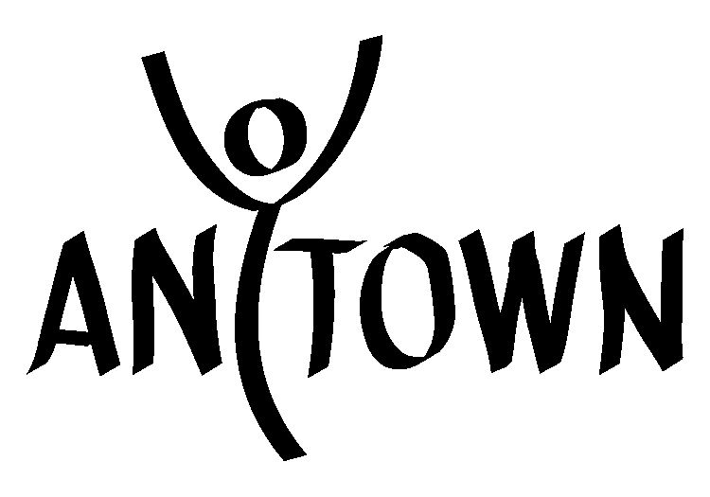
℠

Delegate Leader Application, 2015

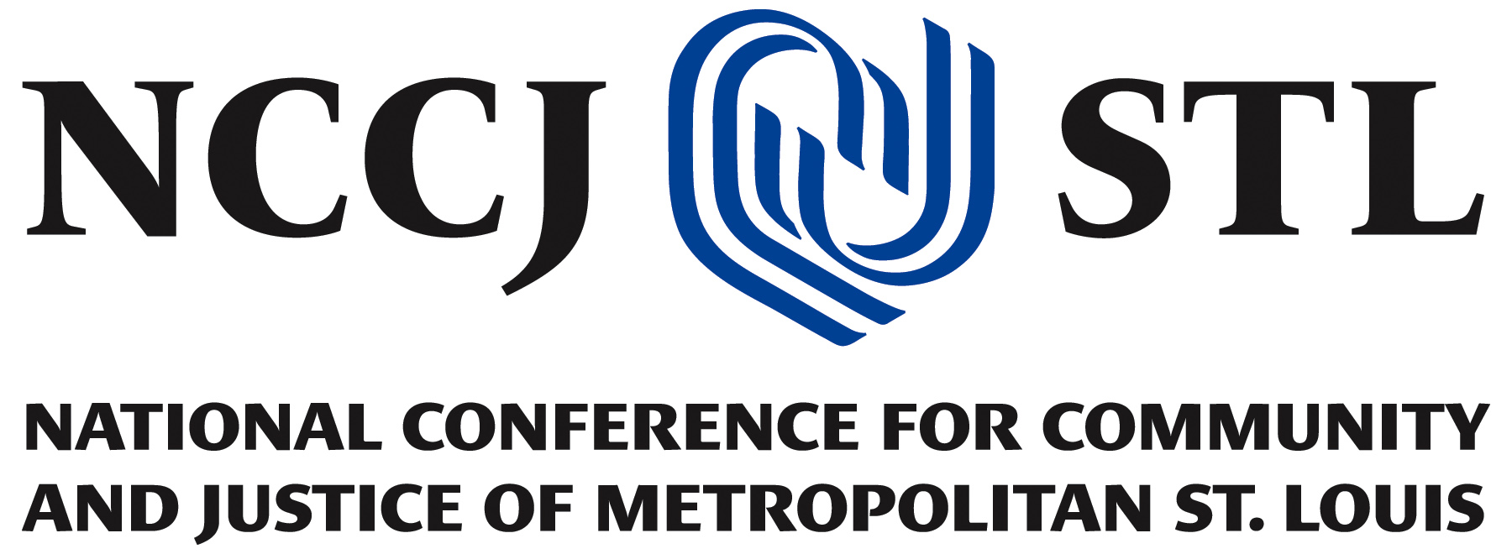

1405 Pine Street, Suite 203
St. Louis, Missouri 63103-2355
Tel (314) 432-2525
Fax (314) 432-2526

Website: www.nccjstl.org
Email: programs@nccjstl.org
Facebook: Anytown Youth Leadership Institute - St. Louis
Twitter: @AnytownSTL

Anytown Youth Leadership Institute ℠

Information:

What is the Anytown Youth Leadership Institute℠?

The Anytown Youth Leadership Institute℠, a program of The National Conference for Community and Justice of Metropolitan St. Louis (NCCJSTL), is a unique residential program for high school age youth. Anytown’s goal is to prepare youth to become skilled change agents who will promote social justice and inclusive communities. Youth participate in experiential learning activities and dialogue sessions designed to increase their understanding of human relations issues and of their own responsibility to create a community based on inclusion, trust, and mutual respect.

When will this year’s Institute take place?
Anytown will have one session this summer with the hopes of having 60 students enrolled. The Anytown 2015 Institute will be July 12-19th for participants and July 10-19th for staff.

Is Anytown℠ like other summer camps?

No. Anytown℠ is more of a personal growth experience than a traditional summer camp. Activities include discussion groups, role playing, learning exercises and presentations on human relations issues such as stereotyping, prejudice, discrimination, ethnic and racial identity, gender issues, sexual orientation, communication and more. While there is some recreational time each day (with activities such as soccer and swimming), most of the time at Anytown is spent exploring human relation issues in various large and small discussion groups.

What do Delegate Leaders do?
Delegate Leaders have three primary responsibilities, engage with the Anytown curriculum as a participant, taking the opportunity to continue their individual social justice journey, assist with program components throughout the Anytown Institute, and model Institute guidelines and community norms, while mentoring first time delegates. For a full description of the roles and responsibilities of Delegate Leaders, please see Part 3 of this application.

Is there training for Faculty members?

The Anytown Youth Leadership Institute℠ requires a highly trained Faculty. To this end, NCCJSTL REQUIRES all Anytown Faculty to complete a comprehensive training process. Faculty attends training over the course of one weekend and two day prior to the arrival of participants. All Faculty must attend both sessions. The date for the residential weekend training for Faculty has yet to be confirmed. We will have a training date confirmed and communicated with candidates prior to scheduling an interview for this position. The second session of training is two days prior to youths’ arrival at the Institute, July 10th and 11th. Faculty training is not only a vital piece of the Anytown Faculty experience, but is a valuable learning and personal growth experience itself. ATTENDANCE AT ALL TRAINING SESSIONS IS MANDATORY unless permission is granted by the Program Director.

Are Faculty members paid?

Anytown℠ Faculty receive a stipend for the Institute. It does not equal the compensation deserved for the important role of Anytown℠ Faculty. As part of Anytown Youth Leadership Institute℠, Faculty will receive an invaluable and rewarding opportunity to impact the lives of youth in the St. Louis Region, and training worth over $1,500. All Institute expenses (lodging, food and mileage) are paid for and Anytown Delegate Leaders will be paid a stipend of $350 per session.

How many participants will be attending?
NCCJSTL hopes to plans to recruit 55-60 participants attend each Anytown℠ session. Participants are supported throughout the week by 17-20 Faculty members.

What about the Institute’s facilities, housing and meals?
The Anytown℠ Institute will be held on the South Campus of the University of Missouri – St. Louis. All sleeping spaces are air-conditioned, as are all meeting spaces. Meals are served three times a day and snacks and water are available throughout the day. Faculty will handle basic medical needs. Medical emergencies are handled by a nearby hospital.

Who can apply to be a Delegate Leader?
Generally, only those who have attended Anytown as a delegate qualify to serve as a Delegate Leader. NCCJSTL encourages people of all racial, religious, ethnic, gender, sexual orientation, class, cultural, physical ability, and other identity groups to apply.

How do I apply?

Please complete all 6 sections of the enclosed application.
If you are younger than 18 years of age, you must have a parent or legal guardian sign section 6.

Once all sections are complete, make a copy of the application for your own records and return the application to the NCCJSTL office by mail, fax, or by e-mail at programs@nccjstl.org.

NCCJSTL, Anytown Youth Leadership Institute℠
1405 Pine Street, Ste. 203
St. Louis, Missouri 63103-2355

Fax: (314) 432-2526

Email: programs@nccjstl.org

Applications are due on March 9, 2015

How will I know if I’m accepted?
Following the application deadline, NCCJSTL staff will contact you to discuss your application. Qualifying applications will do an interview with Program Staff. If you are unable to attend an in-person interview, you will be required to do a phone or Skype interview. Once final staffing decisions have been made by late March, you will be notified of the results. Please call or email Stefani Weeden-Smith to make sure that your application has been received.

IMPORTANT NOTE:
There are many factors that go into the selection of Anytown℠ Faculty. Among them is your experience with anti-oppression work both in and outside of Anytown℠, the identities that you hold, as well as the number of applicants that apply with your same identities.

It is important to remember that we receive many more applications than there are Faculty positions available, so please apply again for a future Anytown℠ Faculty position if for any reason you are not a part of the 2015 Faculty.

(Please keep pages 2-3 for your records)

Delegate Leader Application: Part 1

Contact Information

Instructions:
This application is to be completed by an applicant by printing or typing in responses.

Please
- fill out requested information completely. If you do not know the answer to a question, please write “unknown”.

Anytown 2015 Session
July 10-19, 2015
University of Missouri-St. Louis
St. Louis, MO

Legal First Name Preferred Name*___ _
(If different from legal name/not a nickname)
Last Name___ _
*All mail and non-legal documents will use this name unless you request otherwise

Home Address

City State Zip

Home Phone Cell Phone Twitter Name:

School/Employer

Date of Birth Age Grade
(If applies)

SS # (for use on background check)

Email ___

T-Shirt size (please check one)

* Small * Medium * Large * X-Large * XX-Large
* XXX-Large * Other ________

* After Anytown, a telephone/address/e-mail list will be distributed to all participants and faculty. Please check this if there are parts of your contact information that you want to be left off the roster. Please list what you would like to appear on the rosters, (faculty roster and participant roster) on the lines below.

Delegate Leader Application: Part 2

Demographic Information

Instructions:

The information in this section is used to ensure that we have as diverse a staff at Anytown as possible. Only NCCJSTL staff will see this information. Please check all boxes that apply.

1) Ability Status: Please check all boxes that apply
* Blind/Visually Impaired * Deaf * Developmental Disability * Learning Disability
* Mental Illness (please specify) __ __ * Physical Disability (please specify) __ __
* Temporarily Able-Bodied * Other _ __

2) Gender Identity: Please check all boxes that apply
* Man * Transgender/Gender Variant * Woman * Other

3) Racial / Ethnic Background: Please check all boxes that apply
* American Indian / Native American
* Asian / Asian American
* Bi-Racial / Multi-Racial (please specify)
* Black / African American
* Jewish
* Latino (a) / Hispanic / Chicano (a)
* Middle Eastern
* Pacific Islander
* South Asian
* White / Caucasian / European American
* Other (please specify) __ __

4) Religious Affiliation: Please check all boxes that apply
* Atheist * Baha'i * Buddhism * Catholic * Christian
* Deist * Eckankar * Hinduism * Islam * Judaism
* Native American * New Age * Nonreligious Secular/Agnostic
* Protestant Christian * Scientology * Sikhism
* Spiritualist * Taoist * Unitarian Universalist
* Wiccan/Pagan/Druid * Other

5) Sex: Please check all boxes that apply
* Female * Intersex * Male * Transsexual * Other

6) Sexual Orientation: Please check all boxes that apply
* Bisexual * Gay * Heterosexual * Lesbian
* Pansexual * Queer * Questioning
* Other (please specify)

7) Socioeconomic Class: Please check the one that most closely reflects your current status
* Lower/working Class * Lower Middle Class * Middle Class * Upper Middle Class

* Upper Class * Other (please specify)

Please use the following space to tell us any additional information about your identity that you would like to share: (For example physical ability, immigrant status, etc.)
___
Delegate Leader Application: Part 3

Training Dates

If chosen to be a part of the Faculty, you must attend all training components for your Institute or you cannot be part of Faculty.

The weekend training dates for Anytown Faculty 2015 are still being finalized. NCCJSTL will notify candidates of the training dates prior to the interview portion of this application process.

Delegate Leader Job Description:

There are two roles, besides the Program Manager, at Anytown: FaciliTrainers and Delegate Leaders. While each role has its own set of responsibilities, the faculty works together as a unified team to implement the Anytown program. For a list of the FaciliTrainer roles and responsibilities, please review the FaciliTrainer, Anytown 2015 application.

Delegate Leaders:

Delegate Leaders are graduates of Anytown and are interested in returning to Anytown to further develop their leadership and facilitation skills, and positively contribute to delegates’ Anytown experience. Delegate Leaders assist FaciliTrainers and Program Staff with the execution of the Anytown program.

The key responsibilities of Delegate Leaders include modeling community norms and Institute guidelines for first time Anytown delegates, encouraging and engaging first time Anytown delegates in following these norms and guidelines, assisting with elements of the Anytown program (ex. Table Groups, Organized Fun Time, and Evening Programming), continuing their own social justice journey by participating in Anytown curriculum, and assisting delegates with trusting the Anytown process. While these are the key responsibilities of Delegate Leaders, additional responsibilities may be assigned at Anytown.

Each Delegate Leader will be paired with a FaciliTrainer mentor during the Anytown process. Mentor/mentee pairs will work together to plan and implement a club for delegates and will serve as a resource to each other in the execution of Anytown program components.

Delegate Leader Application: Part 4

Staff Questions

Instructions:
Please answer all the questions below. If completing this section electronically, please place your answers in the text box provided under each question. If you are not completing this application electronically, please use additional pieces of paper to respond to questions below.

- What year did you attend Anytown? How have you been involved in anti-oppression work since your Anytown experience and how has Anytown helped shape this work?

- What personal learning goals would you like to accomplish at this year’s Anytown as a Delegate Leader?

- What specific qualifications, strengths, or insights would you bring to the position?

- Why do you want to attend Anytown again?

- What challenges do you foresee returning to Anytown in a new role? How do you anticipate overcoming those challenges?

Delegate Leader Application: Part 5

Statement of Philosophy

NCCJSTL’s Anytown Youth Leadership Institute℠ is guided by the following philosophical principles. Your signature below means that you have read and understand our philosophy and that you can implement the Anytown program in accordance with these principles.

- NCCJSTL’s work covers all forms of discrimination and oppression. However, the Anytown Youth Leadership Institute focuses on the multiple manifestations of discrimination and oppression that are based on one’s gender, sex, sexual orientation, socio-economic class, and race (i.e. sexism, genderism, heterosexism, classism, and racism) and the relationship between these identities and forms of oppression. NCCJSTL believes that there is no hierarchy of oppression; no one issue or identity is more important than another. No form of oppression can be dismantled until all forms of oppression are dismantled.

- NCCJSTL believes that in order to promote understanding and respect across groups and to dismantle oppression, we must acknowledge the dynamics of power and privilege and the role they play in creating attitudes, behavior, and practices that support systems of exclusion and oppression.

- NCCJSTL believes that all members of society at some time may feel the impact of systemic oppression, overt or covert, intentional or unintentional, conscious or unconscious.

- NCCJSTL’s work is about issues, not about guilt or blame.

- Age issues on staff occur and need to be processed. Everyone needs to exercise his/her/hir authority to speak and be recognized.

- Upper and middle class white male able-bodied heterosexuals are not the enemy. Be aware of the inherent need to have a scapegoat.

- You do not have to be a member of a targeted or a privileged group to work with that group. You may at times be called upon to work with a group outside your own life experience and we ask that you be aware of how your issues, and/or their issues may show up.

DO NOT SIGN UNLESS FULLY UNDERSTOOD

__ ______ __ __

Applicant Signature Date

Delegate Leader Application: Part 6

Consent Form/Waiver

Instructions:

Please read and sign. If you are under 18, please have both the applicant and the parent/guardian sign. If this application is submitted electronically, and the applicant is under 18, this consent form needs to be printed, signed and returned to NCCJSTL in order to be considered for the Delegate Leader position.

- I understand that the Anytown Youth Leadership Institute℠ is an intensive human relations workshop that deals with mature subject matters. I understand that workshop topics will include values clarification, self-esteem, stereotypes and prejudice, interpersonal communication, racial identity, racism, sexism, genderism, heterosexism, classism, family issues, institutional and personal power, and more.

- I understand that Institute participants and staff often find it to be an emotional experience. Throughout the week, participants and faculty may experience confusion, anger, joy, sadness, frustration, hope and more as they learn. I assure you that I (my child) have no known mental or emotional disorders or sensitivities which would interfere with my (my child’s) participation and that I (my child) am capable of handling the subject matter and emotional nature of this program.

- I understand that although NCCJSTL has taken precautions to provide proper organization, supervision, instruction, and equipment for each activity, it is impossible for NCCJSTL to guarantee absolute safety. I also understand that each participant shares the responsibility for safety during all activities and I assume that responsibility for myself (for my child). I waive any claim that may arise against the Board of Directors of the NCCJSTL, Inc. and/or its employees, agents, lessors, volunteers, or lessors including those claims that may arise from the negligence of NCCJSTL, Inc.; its Board of Directors; and/or its employees, agents, lessors or volunteers.

- If the Program Director must send me (my child) home for any reason, I agree to leave immediately (pick up my child within four hours of the Program Director’s call) - unless other arrangements are made with the Program Director. For parents/guardians: I understand that I may be called at any time of the night or day to arrange for my child’s transportation home and that I will be responsible for all costs associated with such transportation.

- I have read and understand all the enclosed documents in this packet.

DO NOT SIGN UNLESS READ AND FULLY UNDERSTOOD

Applicant Signature __ ___Date ___ ___

Parent / Guardian Signature __ ___Date ___ __

Anytown℠ Faculty Conduct Agreement

I, _ _, understand that if I am selected as a Faculty member of the Anytown Youth Leadership Institute℠ that it is my job to promote an atmosphere that is supportive of participants for their safety and growth.

As a Faculty member, I understand that I am on duty from the moment I arrive on-site until the end of the program when the last delegate has left Anytown℠. As such, I will be present and engaged in all activities unless I have obtained the expressed consent of NCCJSTL’s Program Director.

I understand that Anytown exists for the benefit of the participants, that all decisions are made with the best interests of the delegates in mind, and that the needs of the delegates come first and may even supersede my own needs. I further understand that all Faculty are expected to take a guiding, supporting role, and are expected to exercise restraint, maturity and good judgment when confronted by issues that are personally difficult.

I recognize that the content of the week is emotionally and mentally intense, and that issues may come up for me as an individual that require personal support. I also recognize that there may be times when I have trouble placing the needs of the delegates above my own, or when my needs may conflict with the delegates’ needs or the responsibilities of my position. If either of these situations occur, I agree to seek out the support I need in a manner that does not interfere with the delegates’ process or the community.

I understand that the Program Director, Program Specialist, and Program Faculty are available to me as resources, and I agree to utilize them as necessary rather than looking to the delegates, or a particular delegate, for support.

I understand that there shall be no sexual activity or sexual interaction, no planning for such activity or interaction, and no intimidation between Faculty members and participants or Faculty members with each other while at Anytown. Breach of this policy will result in my immediate dismissal from the Anytown Institute. I further agree that my behavior will be consistent with the general rules and guidelines for all members of the Anytown community.

I understand that physical contact between Faculty and delegates is restricted to hugging or touching on the arms or shoulder in a supportive manner. Hugging should not be made a norm of the Institute by the Faculty. Any physical contact will stop immediately if the participant becomes uncomfortable with the contact. As a Faculty member, I am responsible for exercising sensitivity and recognizing discomfort on the part of the participant.

I understand that the presence or use of alcohol, or any non-prescriptive drug is prohibited. Limited use of nicotine is allowed. I accept that my possession/use of any prohibited items at Anytown may be cause for immediate dismissal and/or other punitive action such as not being a part of future Anytown faculties or my Anytown pay being withheld.

Although the Faculty norm is one of cooperative decision-making, the Anytown Program Director or authorized NCCJSTL Faculty person has the final word about all program-related decisions and Faculty and delegate discipline (up to and including a Faculty member’s and/or delegate’s dismissal). Accordingly, I fully authorize the NCCJSTL Program Director to make program-related and disciplinary decisions on my behalf. In addition, if I am asked to leave Anytown, I agree to voluntarily remove myself from the program and grounds immediately, at no cost to NCCJSTL.

I understand that failure to adhere to any part of this agreement will result in my immediate removal from the Anytown Youth Leadership Institute and/or other punitive action such as not being a part of future Anytowns and/or my Anytown pay being withheld.

I hereby state that I have read and understand this agreement and will adhere to its contents.

DO NOT SIGN UNLESS READ AND FULLY UNDERSTOOD

_ ____ ___ ______
Signature Date
___ _______
Name (Print)

